Our Story
During early years of my daughter, it was a regular routine of mine to visit doctors because of cough, fever and sore throat. Medicines immediately treat the issue but do not allow the immunity system to build properly.
Desperate for a natural alternative, I remembered my grandmother’s advice: a teaspoon of pure, unadulterated honey can cure organically and boost immunity system in children above 3 years of age.
Fascinated by her recovery after a spoonful of raw, local honey, I started learning more about the remarkable antibacterial and anti-inflammatory properties that make honey a natural remedy for sore throats and minor ailments.
What began as a personal mission to comfort my sick child organically evolved into a source of wellness for my entire family.
After travelling extensively in search of pure unadulterated organic honey, I eventually built a thriving organic honey business to share nature's remedy with others.
XXXXX is a brand owned by Srinika Agro Foods, which specializes in Organic, Unadulterated premium Honey and Pickles. Our diverse product range is inspired by great quality and great taste.

Our Mission
To share nature's remedy with others and to make delicious food that’s better for you!

Our Product Basket

1. Honey Variant
a. Rose Petal Honey – Heney Bee
b. Ginger Honey – Heney Bee
c. Dry Fruits Honey – Heney Bee
d. Wild Honey (Black Forest) – Bumble Bee Honey

2. Pickle Variants
a. Oal Ka Achar (Jimikand/ Oal Pickle)
b. Kathal ka Achar (Jackfruit Pickle)
c. Amla ka Achar (Amla Pickle)

3. Sirka
a. Jamun ka Sirka (Indian Black Plum Vinegar)
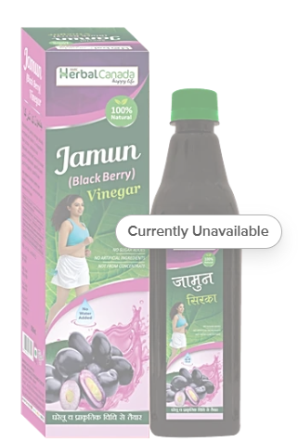
Sample Photo
(high quality images will be provided later)
Where to Buy

- Door step collection
SRINIKA AGRO FOODS,P-309, HARI SAVA MATH, KOLKATA, WB – 700070
- Company Website: www.Srinikaagrofoods.in
- Instagram id
- Facebook id
- Online Portal


Privacy Policy
By mere use of the website, you expressly consent to our collection and use and disclosure of your personal information, including but not limited to your consent for sharing your information. If you do not agree please do not use or access our Site.
We do not collect or store Credit Card or Debit Card or any of your banking information as it is directly transmitted through the payment gateway provider to the payment network or bank.
Note: Our privacy policy may change at any time without notice. To make sure you are aware of any changes, kindly review this policy periodically.

Refund Policy
Product returns:
Once products are delivered to you and accepted as accurately and as per the original order, there is no refund or exchange possible. To return any items that are damaged or expired or not as per your original order, please return these products to the delivery person along with a remark on the delivery challan.
Please contact customer service by email through the contact us link on the website within 24 hours of delivery. Mention the return of products along with the order number, and the date of delivery along with supporting images and videos. These must include an image of the shipping label and invoice.
All returned items must be accompanied by a copy of the original receipt, a return / exchange authorization number and in unopened, saleable condition. Images of the condition of the package upon receipt by you shall always be an added benefit to expedite the claims at our end. Postage and charges for return of these will not be refunded. Please note that in any case we cannot offer exchanges or refunds on any sale, opened or used products. Please allow one to three weeks from the day you return your package for your refund request to be processed. You will be contacted once your return is complete.

Shipping Policy
Shipment of Products: We offer free shipping for all pre-paid purchases. Cash on delivery transactions will be charged Rs.30/-. Discount codes are not applicable to products that are already on sale.
Delivery Charges: Shipping and handling rates may vary based on product, packaging, size, volume, type and other considerations. The shipping and handling charges are given at the time of check out and consumers will know about this before making payments.

Customer Support  Contact Us:  9.30 AM to 6.30 PM - Monday to Friday  +91 74398 77939  srinikaagrofoods@gmail.com   | Brand Owner & Marketed by  SRINIKA AGRO FOODS,  P-309, HARI SAVA MATH, KOLKATA, WB – 700070    LIC NO: 22823043000076  Manufactured by  XXXX  Zzzzzzzzzzz    LIC NO:

